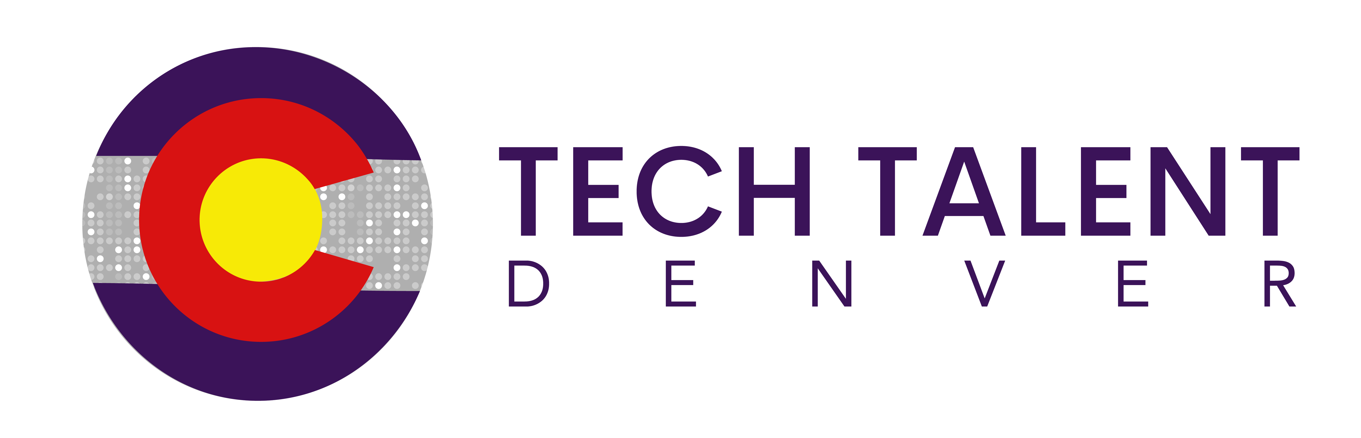
AGENDA
February 27, 2020
8:00am – 9:30am (Ardent Mills)
8:00am Coffee and Networking

8:15am Welcome and Introductions
- Industry Co-chair: Chris Meyerpeter, Ardent Mills
- Industry Co-chair: Michael Simpson, Pairin

8:30am 2020 Strategic Goals
- Industry Awareness to Youth

- Summer Internship Program Creation:

- Increase Webtool Utilization – Talent Generation Tool

9:10am Q & A

9:20am Closing Remarks/Calls to Action
- Create Internship Task Force Committee
- Meeting cadence for 2020- 4 meetings a year with Taskforce calls/meetings as needed
- Tech Talent Denver Evening Celebration/Meeting May 7th, more details to follow
- Looking for Industry hosts for the following meetings: (if interested please let Shannon know)
- Q2 – May 7th @ Commons on Champa
- Q3 – Aug. 6th @ TBD
- Q4 – Nov. 5th @ TBD
- Create Profile on WebTool https://techtalentcolorado.com/

